Scientific Revolution Webquest
Directions: You will need a pen/pencil, this worksheet from my website, and a pair of earbuds in order to listen to the videos. Watch the videos and then go to the websites in order to answer the questions.

Nicolas Copernicus
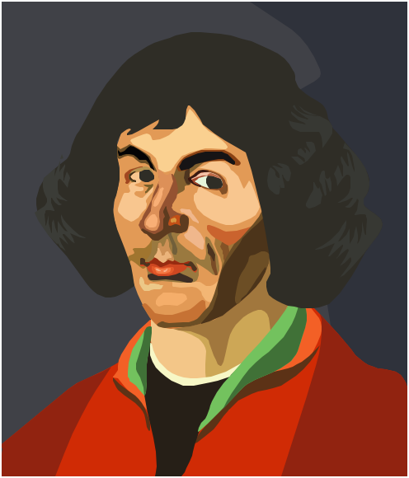
Video: http://www.history.com/shows/the-universe/videos/beyond-the-big-bang-copernicus
Copernicus Site http://www.history.com/this-day-in-history/copernicus-born
Explain the Ptolemaic version of Geocentric Theory?

How was Copernicus’ Heliocentric theory different?

What three later Scientific Revolutionaries were heavily influenced by him?

Johannes Kepler
Video: http://www.youtube.com/watch?v=a19LTnXkyVQ
Kepler Site: http://www.history.com/this-day-in-history/universe-is-created-according-to-kepler

How did Kepler improve on Galileo’s ideas of orbital movements?

What were his laws based on?

Which English Scientist did he influence?

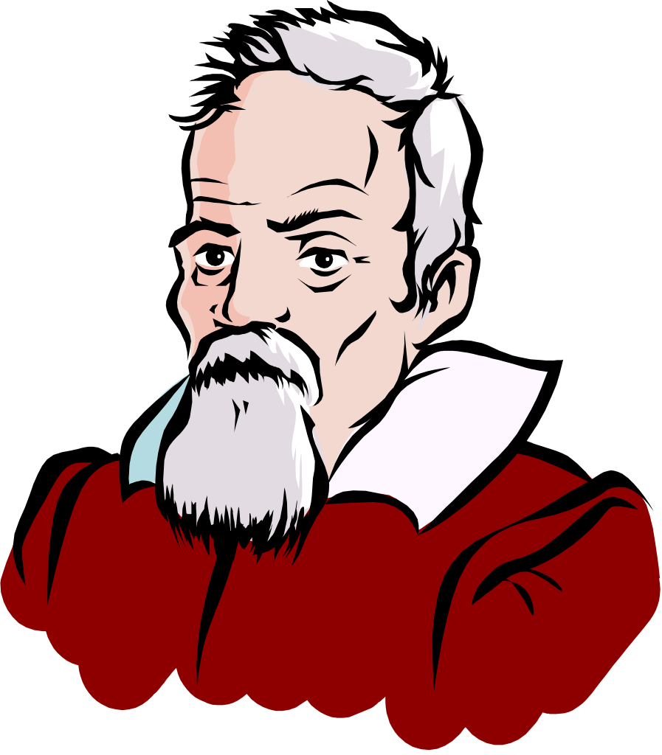
Galileo Galilei
Video: http://www.history.com/shows/the-universe/videos/beyond-the-big-bang-galileo-galilei
Galileo Site: http://www.history.com/topics/galileo-galilei
What was the ‘Starry Messenger’?

Who did it contradict?

Which Scientific Revolutionary influenced him?

What did the Roman Catholic Church do to him for his support of Heliocentricism?

Search the site to explain what Eppur si muove means and how it applies to him.

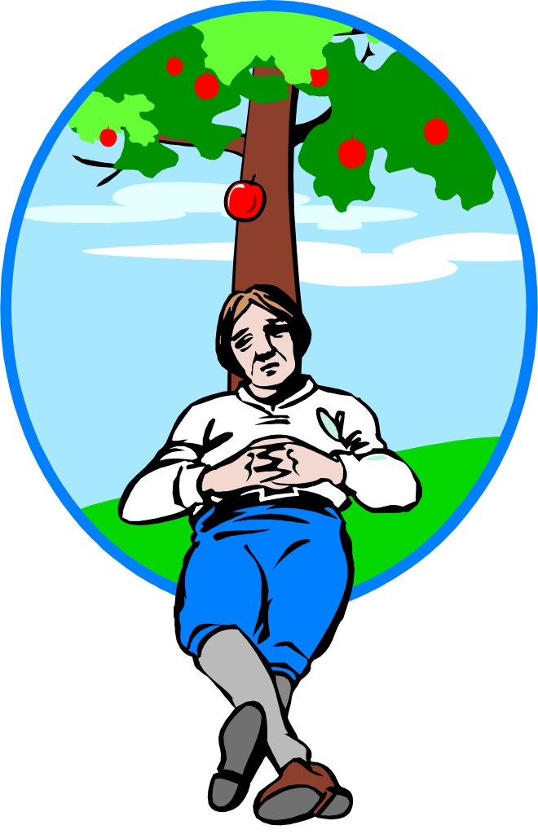
Sir Isaac Newton
Video: http://www.history.com/videos/isaac-newton-and-a-scientific-revolution#isaac-newton-and-a-scientific-revolution
Site: http://www.biography.com/people/isaac-newton-9422656

Which earlier Scientists influenced Newton? (hint, you have studied them)

What Theory is Newton most commonly known for and how does it apply to Science?

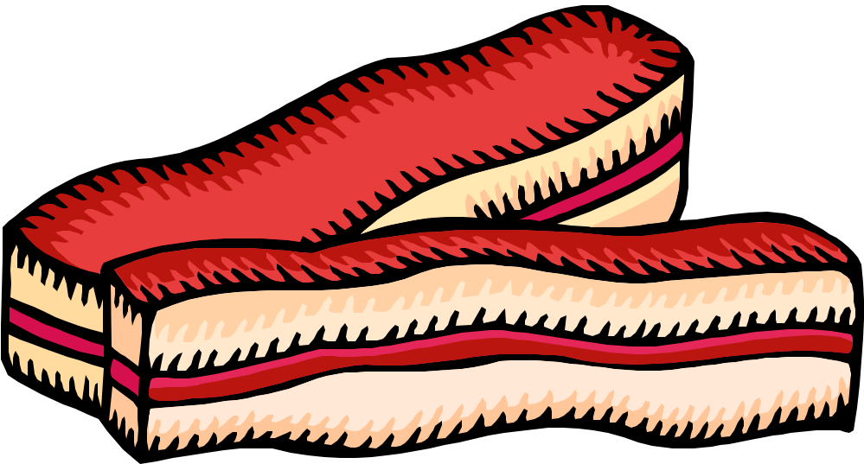
Sir Francis Bacon
Bacon Site:http://www.bbc.co.uk/history/historic_figures/bacon_francis.shtml
Which Scientific ideas did Bacon dispute?

What were his assumptions in Novum Organum about the scientific method?

